SHADOW FORCES – Thinking Like An Artist
It all started when I was looking at some of the new satellite shots.
I saw this one:
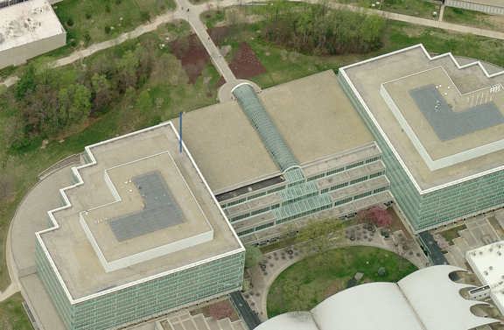
and I thought to myself ... what are those brown pyramids out front?
A close up revealed that these were at the entrance to the building, out by the compass rose, etc:
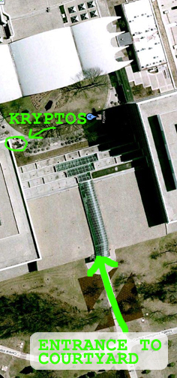
A close up of the area:
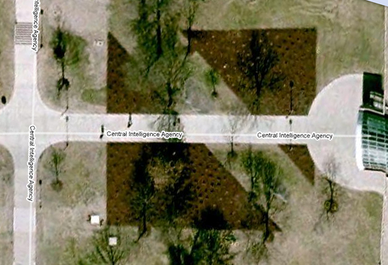
And so I thought about this for a while, until I saw THIS photo:
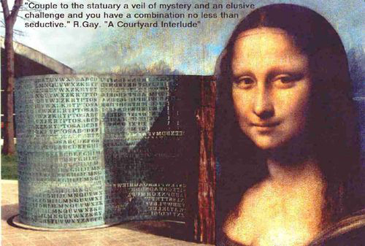
... and I thought to myself ... “Ah, ha! Shadow Forces!”
I rotated the brown pyramids and saw that the space between them looked oddly the same as these shadows:
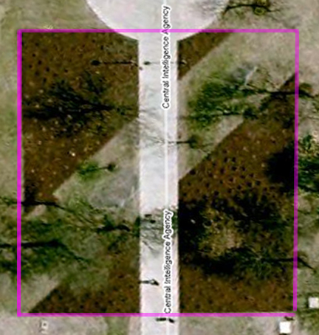
but moreover, I thought to myself ... hmmm ... isn’t this right where the letters KRYPTOS cut through the Vigenere Tableau?
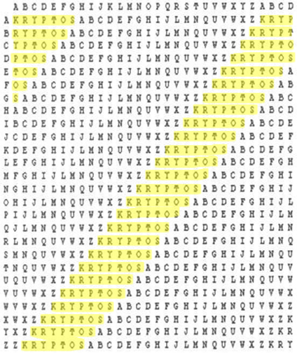
(scaled Elonka table; not to scale)
Notice how the angle of KRYPTOS seems to be at the same angle and separates the tableau into two triangles; this is something visual that I think Sanborn would have noticed. Especially note the way the top right corner touches both the top and the right side of the tableau ... just as the brown pyramids in the front of the building. Also note how the bottom right corner leaves off one letter from the bottom, again, exactly the way it looks in the overhead view of the brown pyramid shapes, where the bottom corner does not touch all the way to the bottom right – there is a space there.
Could this be one giant coincidence?!
Here is a view of a different tableau replica that is more akin to the shape of the two brown pyramids:
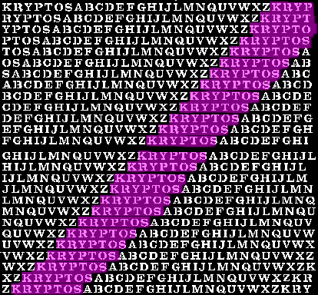
And, if you want all the KRYPTOS letters highlighted:
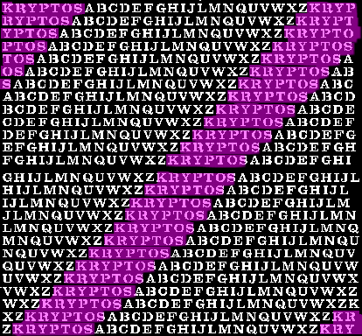
I superimposed one such tableau over a photo of the KRYPTOS sculpture, and guess what?
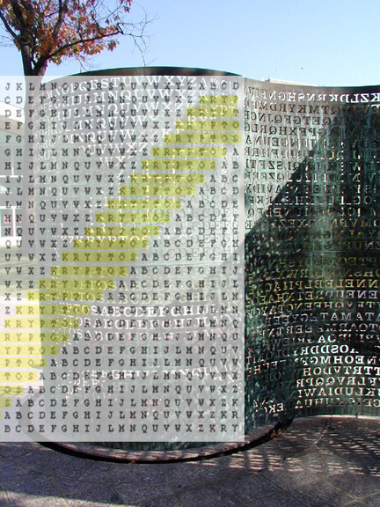
... the angle seems to match!
SHADOW FORCES INDEED! (Or me just thinking I know how to think like an artist and am way off ... )
I inserted a compass rose over the shadow line and ... another almost perfect match! Notice, also, how these are these compass points coincide with the compass rose out in front, by the brown pyramids!
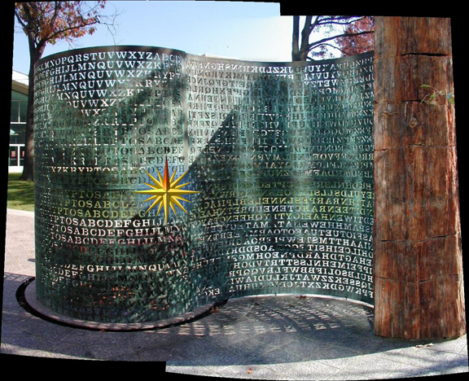
I started looking at photos of KRYPTOS to see how the shadows behaved, and noticed that in most of them, the shadow lines were similar:
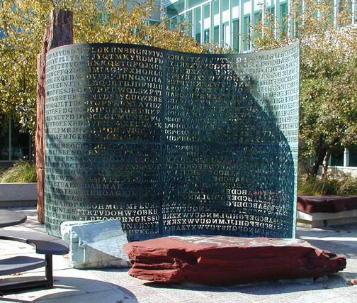
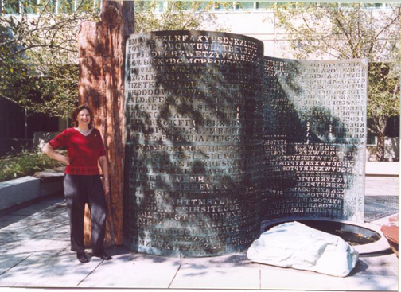
(Elonka at KRYPTOS)
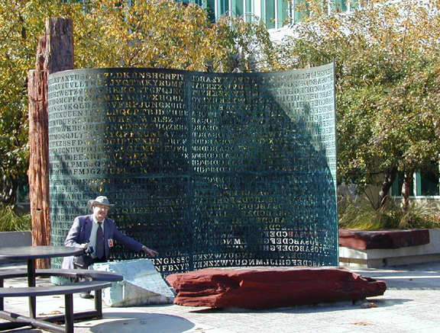
(Jim Gillogly at KRYPTOS)
Does it seem like everyone is showing up at the same time of the day ... or are the shadows always this consistent?
And wouldn’t this be something THAT Sanborn would have studied in depth as an artist, and as demonstrated by his past and post works? SHADOW FORCES would seem to indicate this, as does the photo of the model, indicating primary and secondary lighting that he most likely studied, and seems to correlate with the position of the sun at two times of the day (need verification of that, though):
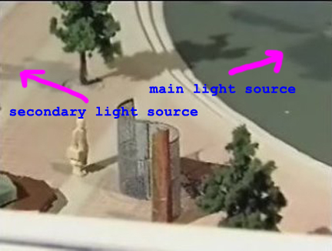
What if what’s in plain sight are the two brown pyramids ... but wait ... have they ALWAYS been there?
Additional notes of curiosity:
Sanborn used the keyword “shadow” (TEHb in Cyrillic) on the 1997 Cyrillic Projector. I’ve always felt that he’s left clues in his later artwork, what if that was one of them? By virtue of the nature of a Vigenere Tableau itself, the location of the keyword in the modified Vigenere cipher will locate itself in approximately the same place, but Sanborn used a 31-character tableau on KRYPTOS, while using a 32-letter Cyrillic alphabet on the Cyrillic Projector, so what are the chances that the tableaus should look so similar:
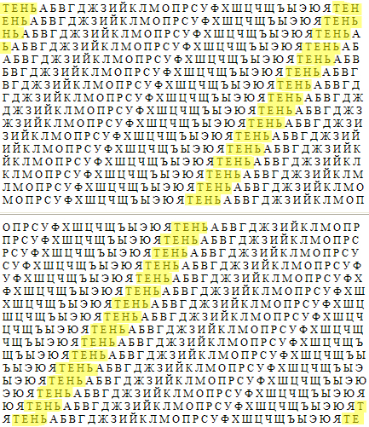
I think it looks like a clue.
Then I remembered something my niece Kristyn said on the day I hooked her on KRYPTOS waiting for a flight to London at LAX for 8 hours last year:
“What if it needs to be rotated 45 degrees?”
And it was her FIRST day! :D
Of course, Diconaxes new arrangement Pyramid Capstone (Excel in his folder) came to mind, as did one of my own newbie works, a Pyramid Overlay (in my files). Additionally I found this KRYPTOS grille, based on somewhat of the same idea (but without so much mention of “shadows”):
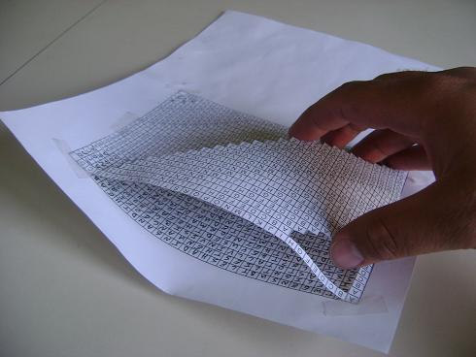
(don’t know where I got this now ... sorry to the creator)
Turning the Vig table 45 degrees so that KRYPTOS is straight across the middle may hold the key. This idea also gives meaning to the concept that K4 is the “apex of the pyramid.” If the matrix for deciphering K4 is based on rotating the text 45 degrees into pyramids, well, I know what I’ll be working on for the next few days.
As an artist, and thinking visually and steganographically, I think that this is something Sanborn would do.
Ideas anyone?
Donna B
“trying to think like an artist”

